Village of Black Earth
Invites you to attend training on
Wednesday, October 9th
6:00p-8:00p
This event will be held at
Village Municipal Bldg. Meeting Rm.
1210 Mills St.
Black Earth, WI
Presented by: Dane County
Deputy Josalyn Longley
Training is for Adults and is FREE!

- The average Active Shooter event lasts 4 - 8 minutes.

- Over 70% of Active Shooter incidents are over in 5 minutes or less.

- National average for Law Enforcement response is 5 – 6 minutes.

Plan and Prepare!

Preparedness for Active Shooter and Violence
within the Community

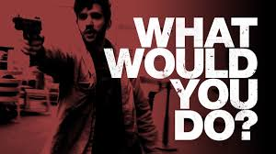

Questions contact Deputy Longley 608-977-1300/ Longley@danesheriff.com
OR Cindy Holmes 608-215-6615/ holmes.cindy@danesheriff.com
Sponsored by The Dane County Sheriff’s Office and Black Earth DCSO Contract Deputies

